Dashboard for PSSNA.

Tab navigation interactive dashboard.

Tab 1 Sales Status

Deck 1: Invoiced Net Sales: Shows Current month Sales with option to show prior

Selection by Distribution Channel and Material Group.

Data: MTD Net Sales, Forecast, % Net/Forecast, Business Plan (Quota), % Net/ Business Plan (Quota), Prior Year Net, % Net/Prior Year Net, Prior Year FY to Date, % Current FY to Date, Prior FY to Date.

Deck 2 Order to Sale

Data: Distribution Channel, Open Orders $, Deliv CR (Delivery Created), Deliv CH (Delivery on Credit Hold), Delivered Drop, Billable, Billed, Sum (Delivered Drop, Billable, Billed, Forecast), %Total/Forecast, Budget, %Total/Budget.

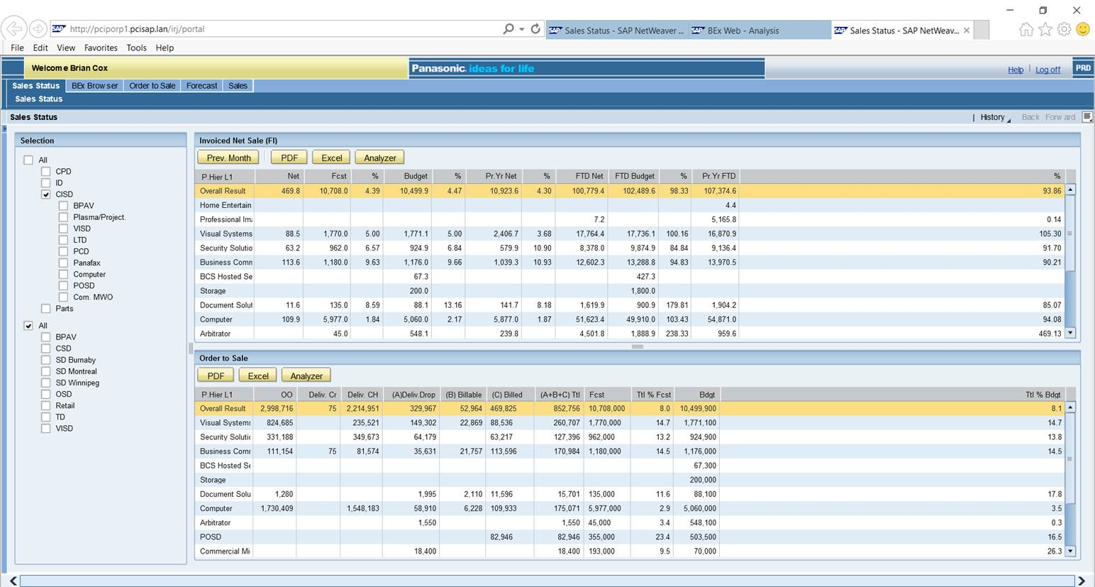

Tab 2 Order to Sale Detail

Deck 3 Order to Sale Detail/Top Ten by Material

Selection by Distribution Channel and Material Group.

Data: Material, Open Orders $, Deliv CR, Deliv CH, Delivered Drop, Billable, Billed, Sum (Delivered Drop, Billable, Billed, Forecast), %Total/Forecast, Budget, %Total/Budget.

Deck 4 Order to Sale Detail/Top Ten by Sold to

Selection by Distribution Channel and Material Group.

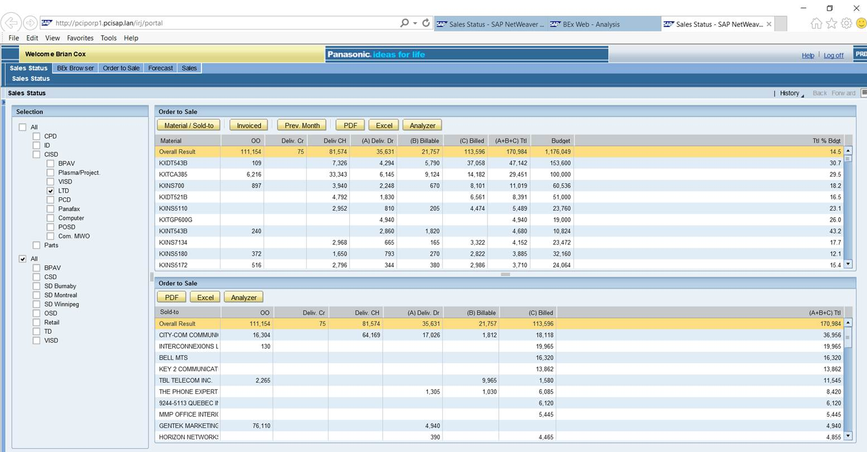Data: Material, Open Orders $, Deliv CR, Deliv CH, Delivered Drop, Billable, Billed, Sum (Delivered Drop, Billable, Billed, Forecast), %Total/Forecast, Budget, %Total/Budget.

Tab 4 Sales Analysis by Employee

Selection Criteria: Dist Channel, Material Group, Material Family, Material, Sales Sector, Sales Vertical

Deck 5 Sales Analysis by Employee

Data: Sales Employee, Open Orders $, Deliv CR, Deliv CH, Delivered Drop, Billable, Billed, Sum (Delivered Drop, Billable, Billed, Forecast), %Total/Forecast, Budget, %Total/Budget.

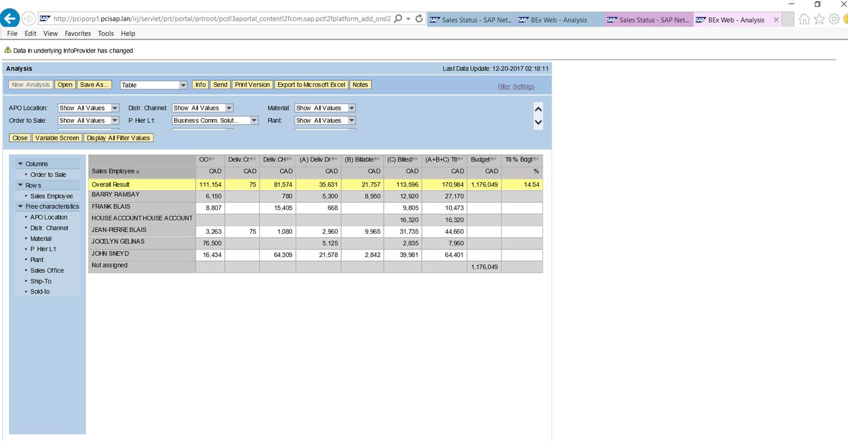

Tab 5: ETA

Deck 6 ETA Data Newly Received orders over 90K (received since the last workday)

Data: Material, Order Quantity, Net Value, Unit Price, Customer Name, Reseller Name, End User Name

■Newly received orders ($90K+)

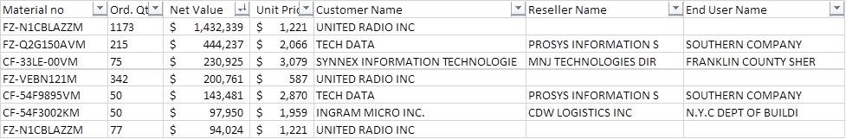

Deck 7: Sales & ETA-IP Status (Net base, excluding service sales)

Stacked Bar chart of Net Values for ETA Status Backorder/Invoiced

Vert Axis Net Value, Horiz Axis : Blocked/Pending, ETA IP, Order Received Month

Data Table below visualization

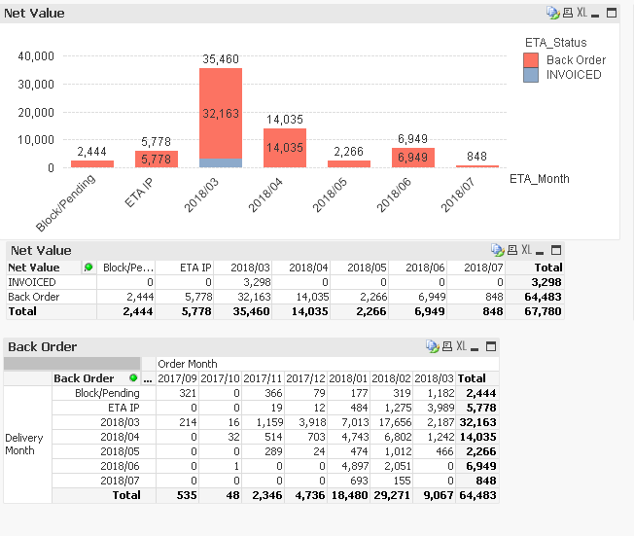

Deck 8 PO in Current Month

2 Charts Chart1: Count of POs Received in Current Month by ETA Order Receipt Date

Vert Axis: Count of POs received, Horiz axis , ETA Receipt Date

Chart 2 Orders Received by Month Vert axis: Count of POs received, Horiz axis, ETA Order Receipt Month

Daily PO status

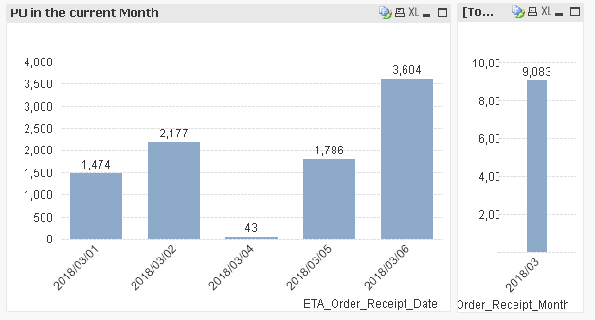

Deck 9 ETA IPxMonth

Summary List Count of Orders in ETA IP status by Order Receipt Month.

Data: Order QTY, Net Value, ETA Order receipt month

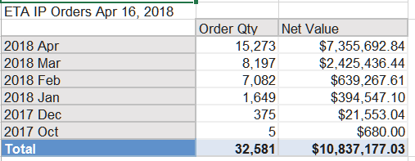

Detail Lists of Orders in ETA IP status by Order Receipt Month

Data: Order Receipt YYYY MMM, Report Date, Order Receipt Date, Ship To Party Name, Sales Order Item, Material Number, Order Qty, Net Value, Order Status, Vendor Name, Eta Date, Ship Date, Confirm Qty, Open Order Qty, Unit Price, Customer PO Date, Customer Po, Customer Name, Delivery Priority, Warehouse Code, Customer Number, SAP PO, SAP PO Item, SAP PO Date, Vendor Code, SPL Number, SPL Revision Number

